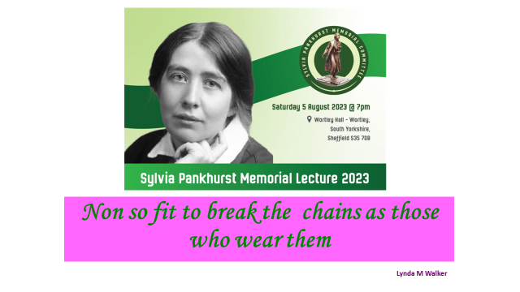
Sylvia Pankhurst, and the link with Ireland Lynda Walker 5.08.2023
I want to thank the National Assembly of Women and Sylvia Pankhurst Memorial Committee, for inviting me to do this presentation which will explore some links Sylvia Pankhurst’s with Hanna Sheehy Skeffington and James Connolly, their connections with the labour movement the Suffrage movement and Irish politics of the day.
SLIDE 2: Time line The time line shows that Connolly spent little time in any one place but made an impact in internationally
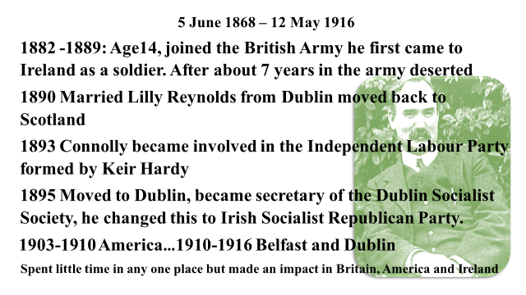
Sylvia and James Connolly
From her writings it is evident that Sylvia was knowledgeable about James Connolly and his politics and she analysed ideals of 1916. They spoke on the same platforms, and Sylvia wrote about him, especially after the Easter Rising-executions. She would have also a been influenced through people that they he worked with like Keir Hardy and in America Elizabeth Gurley Flynn who gives a detailed account of her work with Connolly in the Industrial Workers of the World (IWW-Wobblies) Connolly lived close by her family in the Bronx in 1907. (Rebel Girl p. 73-76 1973) Sylvia met also Elizabeth on the tours in the US 1911/1912, well recorded the book Sylvia Pankhurst Natural Born Rebel by Rachel Holmes (p 309-311; 2020)
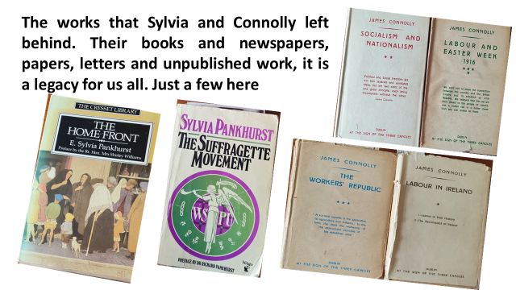
The links between Connolly and Sylvia show they shared key political ideas and principles, this comes through strongly when you consider the research, writing and action they took to fight the poverty and exploitation caused by capitalism, of the lives of working class women and their families. Unlike her mother and sister, Sylvia opposed First World War and conscription. She also believed that the suffragette movement should be based on socialism and that emancipation should apply to all women.
SLIDE 3 Their writngs
The writings that Sylvia and James Connolly left behind in their books, newspapers, papers, letters and unpublished work is a legacy for us all. That Connolly supported the suffrage movement is evident in his work and action. Hanna Sheehy Skeffington noted in her memoirs that Connolly never failed to respond to a call for a meeting of or a protest demonstration. In 1912 he travelled to Dublin to help defend the suffragettes from the attacks that were taking place. In July 1912, there was an upsurge of militancy in Dublin by the suffragettes, several Irish suffragettes got prison sentences for throwing rocks at Dublin Castles windows.
In addition, two English suffragettes Mary Leigh and Gladys Evans initially received a 5 years’ prison sentence, one for throwing a hatchet into a carriage carrying John Redmond and Prime Minister Asquith, the other for setting fire to the curtains at the Theatre Royal where Asquith was to speak. These incidents created a reaction from mobs and Sylvia wrote that “every woman who happened to be in the street was assailed.” (Page 404 The Suffragette Movement; 1977) Having been refused political prisoner status the English women went on hunger strike, the following day the Irish Suffragettes went on hunger strike in sympathy the English, they were the only ones to be force fed. There was a reluctance to force feed Irish women because of the political situation. Sylvia gave details about the prisoners, violence, politics of the situation including the difficulties she had speaking at a meeting in Phoenix Park.
Connolly declared in 1913 that he had never yet seen or heard of any militant action of theirs that he would not have been fully prepared to endorse.
In August 1914 Sylvia was in Dublin to report and attend the inquest of those killed at what became known as the Bachelor's Walk massacre it took place on 26 July 1914, when King’s Own Scottish Borderers attacked “hostile but unarmed” protesters with rifle fire and bayonets - resulting in the deaths of four civilians and injuries to in excess of 30 more. One of those shot was the father of folk singer Luke Kelly. Sylvia writes about visiting the homes of the victims- In that respect she showed interest in the politics of Ireland, separate from the suffrage movement. She cut the visit short when First World War began. (p12-14; 1987)
SLIDE 5 Albert Hall Other speakers:
Of course she did not have to come to Ireland to meet Connolly, one the meetings most written about was when she shared the platform with Connolly in the Albert Hall on 1st of November 1913, in support of Jim Larkin who was imprisoned during the 1913 Lockout. Other speakers included Keir Hardie, George Bernard Shaw, George Russell (AE), Ben Tillett, Delia Larkin, Charlotte Despard, Dora Montefiore, Robert Williams & George Lansbury. Donal Nevin describes the speakers in his book as “a roll call of labour, trades unionist, socialist and feminist leaders.” (p. 460: Gill & McMillan Ltd;2006) It was her appearance at this meeting that caused the final break up with her mother and sister her because of her commitment to socialism, and support for Irish independence.
The Daily Herald (3rd November 1913) describes Connolly’s speech as a masterpiece: “Never a misplaced word never a wasted adjective. Sheer massive arguments and brilliant summary of facts.” “You cannot build a free nation on the basis of slavery. We are against the domination of nation over nation, class over class, sex over sex, but if we are to make of Ireland the Ireland of their dreams and aspirations we must have a free and self-respecting and independent people. You can never have freedom or self-respect whilst you have starvation whether it is the green flag or the union jack that is flying over our heads. If there is nothing in your stomach it matters mighty little what flag is flying.” (Donal Nevin (460:2006)
Larkin got seven months’ imprisonment on the first count of using seditious language. Donal Nevin writes that the British public was outraged at the sentence and there were immediate political repercussions (page 199: 1998) It resulted in him being released on Thursday the 13th of November after16 days. Nevin states “that night after a brush up and a cup of tea he walked down to Liberty Hall where he told the crowd of his intention to raise a fiery cross in England Scotland and Wales. He denounced the British Government and he stated they made a mistake sending me to prison and made an even bigger mistake in letting me out.
Sylvia writes about James Connolly sending a letter from Ireland to Keir Hardy about the work of the suffragettes in Britain. In it he says; “When trimmers and compromisers disavow you, a poor, slum-bred politician, I raise my hat in thanksgiving that I live to see the insurgence of women.” The use of the word trimmer caught my eye, as it is a word not often used now. However, it seemed quite popular at that time and Connolly used it in one of his well-known poems:
Slide 6: Be Moderate:
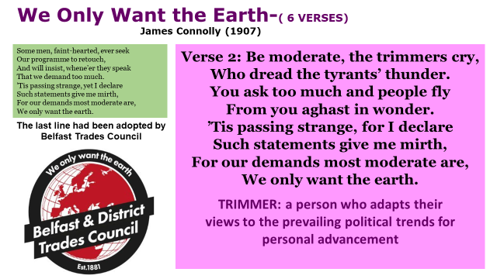
“Be moderate,” the trimmers cry, who dread the tyrants’ thunder You ask too much and people fly from you aghast in wonder.” ’Tis passing strange, for I declare Such statements give me mirth, for our demands most moderate are, we only want the earth.”
The last line was adopted by Belfast and District Trades Union Council. Minutes that I have seen from 1912 in the Linen Hall Library, show that Connolly was active on Belfast Trades Council at that time.
Like Connolly, Sylvia had a working class perspective, she knew and wrote about women working and their life in Britain and Ireland, Sylvia’s political views and her work has been well documented by many historians how she used her artistic skills to portray working conditions of women and also for producing posters, badges and literary works. She describes how women were exposed to hazardous flint dust and fumes and of which she said: “Each was employed by the man she toiled for – the slave of a slave, I thought”
James Connolly also used a similar term in 1915 when he wrote the chapter Woman, in The Re-Conquest of Ireland. He gives a description and analyse of the conditions of the women in the mills, factories and farms. One his best known quotes is “The worker is the slave of capitalist society; the female worker is the slave of that slave.” …. “The daughters of the Irish peasantry have been the cheapest slaves in existence – slaves to their own family, who were, in turn, slaves to all social parasites of a landlord and gombeen-ridden community”
SLIDE 7 Ideology
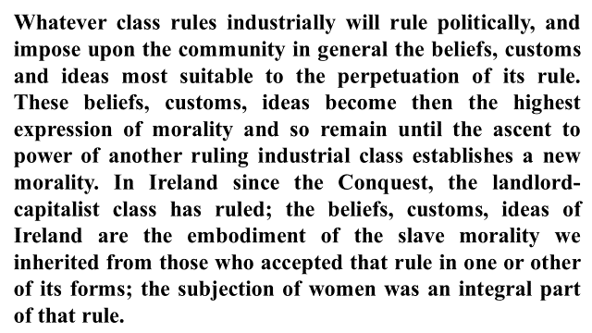
In the next section Connolly identifies the role of ideology, how whatever class rules industrially will rule politically, and impose upon the community in general the beliefs, customs and ideas most suitable to the perpetuation of its rule.
Connolly portrays women as leaders in the class struggle when he writes:
“None so fitted to break the chains as they who wear them, none so well equipped to decide what is a fetter. In its march towards freedom, the working class of Ireland must cheer on the efforts of those women who, feeling on their souls and bodies the fetters of the ages, have arisen to strike them off, and cheer all the louder if in its hatred of thraldom and passion for freedom the women’s army forges ahead of the militant army of Labour.”
But he qualifies this by saying. But whosoever carries the outworks of the citadel of oppression, the working class alone can raze it to the ground. (
If some Irish people were reluctant to make demands on the British Government, Connolly wasn’t. On his return from America to Dublin, he was involved with Irish Women’s Franchise League and Daughters of Ireland, in a campaign to have School Meal Acts and Old Age Pension Act extended it to Ireland. (Nevin: p387-2006)
Connolly wrote “the Protestant workers of Belfast are essentially democratic in their instincts, but not a single Belfast loyalist M.P. voted for the Old Age Pensions’.
He used school inspector reports to show the shocking conditions that school children faced in Dublin and Belfast. And he warned that “Until they the workers unite with us we will be compelled to see Irish Tory employers hiding their sweatshops behind orange flags, and Irish home rule landlords using the green sunburst of Erin to cloak their rack renting in the festering slums of our Irish towns.
EASTER WEEK 1916
Slide: the proclamation:
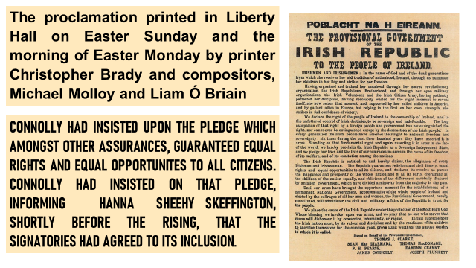
The proclamation was printed in Liberty Hall on Easter Sunday and the morning of Easter Monday by printer Christopher Brady and compositors, Michael Molloy and Liam Ó Briain. Connolly has insisted upon the pledge which amongst other assurances, guaranteed equal rights and equal opportunities to all citizens. Connolly had insisted on that pledge, informing Hanna Sheehy Skeffington, shortly before the rising that the signatories had agreed to it is inclusion. (R.M Fox in Ward p109;1983)
In her book The Home Front, written in 1932, Sylvia devoted a chapter to Easter Week 1916. She begins the chapter: Whilst still we were in Newcastle we opened the papers and learnt that the Irish rebellion had taken place. (P 321;1987) She expresses personal sorrow at the executions and reflects back on her time with Connolly in the days of the Dublin lockout and the Albert Hall platform. She wrote, I mourned him as one who had lived laborious days in the service of human welfare; a man of pity and tenderness, driven to violent means, from the belief that they alone would serve to win through to a better life for the people. (p321)
Here she says, Connolly’s death was more grievous than any, because his rebellion struck deeper than mere nationalism. Yet Connolly was needed so seriously for the after building; him at least should have been spared. (p322)
Patricia Lynch who worked with Sylvia was in Ireland in 1916. She sent an article that gave an eye-witness account of the events of the 1916 Easter Rising in Dublin to Sylvia who published it in The Workers' Dreadnought.

SLIDE 9 An example of a copy of the Workers Dreadnought:
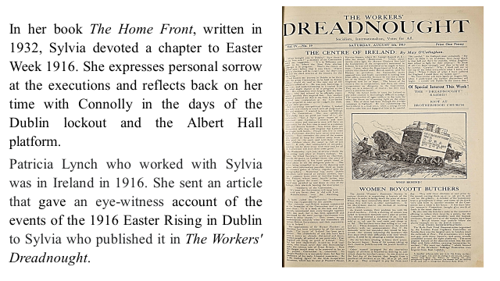

Slide 9: Francis Sheehy Skeffington
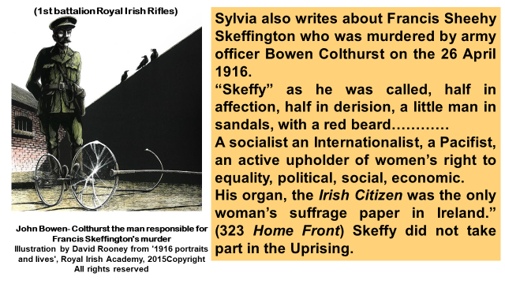
Sylvia also writes about Francis Sheehy Skeffington who was murdered by army officer Bowen Colthurst (1st battalion Royal Irish Rifles) “Skeffy” as he was called, half in affection, half in derision, a little man in sandals, with a red beard…………A socialist an Internationalist, a Pacifist, an active upholder of women’s right to equality, political, social, economic. His organ, the Irish Citizen was the only woman’s suffrage paper in Ireland.” (323)

Slide 10 letter from Nora Connolly:
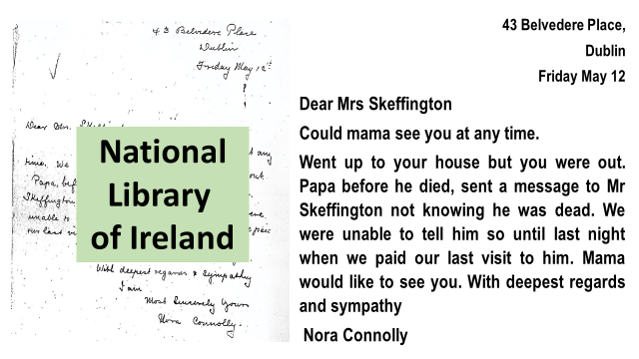
The message that Nora’s father sent to Francis was about Connolly’s his songs, poems, plays and other writings. He wanted Francis Sheehy to take them and sell them to raise money for Lilly and his family.
In this chapter Sylvia gives a critical political analysis that deals with Irish nationalism, aspects of British imperialism, the executions and imprisonment those who took part. It is widely acknowledged that Sylvia was inspired by her father and she writes with some pride about his views on Ireland, stating that “Micheal Davitt an old friend eulogised him as a Radical of the right sort; an Englishman wise and just enough to wish Ireland governed according to Irish ideas. The Doctor was in fact the first English parliamentary candidate to pledge himself to Irish self-government.” (page 63 Suffragette Movement)
Samuel Leverson’s writes in his book James Connolly, that an incident occurred about, ten days before the Rising that sheds additional light Connolly’s personality
“Mrs Sheehy Skeffington happened to meet Connolly on the street and indicated to her in veiled terms that a rising was imminent. While they talked it occurred to her that she was talking to a man who might soon be losing his life. As a free thinker who had thought herself out of Roman Catholicism and still retained a speculative turn of mind, she found herself saying to Connolly “Tell me Jim have you any hope of anything on the other side?” He replied “The British Labour Party? Oh now they won’t lift a finger to help us.” She laughed, and explained what she meant. At this he threw back his head and roared, “Oh no I’m afraid I haven’t time to be thinking about that kind of thing just now.” (page 291 anecdote contained in a letter written to Samuel Leverson by Hanna’s son, the late Owen Sheehy Skeffington-. 1973)

Hanna Sheehy Skeffington
SLIDE 11 Hanna and Francis IWFL
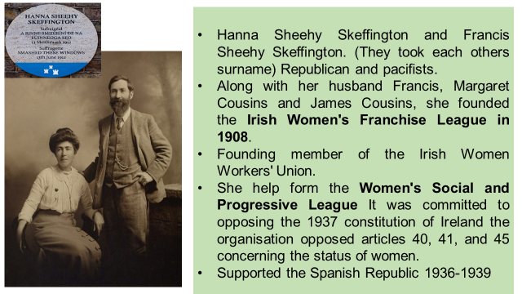

The Irish Women’s Franchise League (IWFL) was founded in 1908 by Hanna and Francis Sheehy-Skeffington, Margaret and James Cousins. They wanted an organisation that used militant action-like the Women’s Social and Political Union, but recognised the need for the need for a separate Irish suffrage society.

There was criticism at time of British Suffragettes active in Ireland, Sylvia writes about this in saying that “if there were any hope of influencing Redmond and the Irish party it could only be by the efforts of Irish Women.” She also makes reference to the WSPU saying though “Irish women were active and virulent the WSPU would not leave the Irish question to them.” (The Suffragette Movement; page 403)
However, there was a lot of two-way traffic of suffrage action between the two countries, a number of Irish women travelled to London to take part in militant suffrage demonstrations some were imprisoned, including Hanna Sheehy-Skeffington and Margaret Palmer, who were imprisoned in Holloway. (Mary Cullen Owens; p39 1984) Of course Constance Markievicz’s sister, Eva Gore-Booth worked alongside Esther Roper in Manchester drawing the close links between the struggle for women's rights in industry and the struggle for women's right to vote
The Field Day Anthology Vol V published what is described as the only detailed memoir written by an active Irish suffragette. Here Hanna explains how the “leaders of the movement in England were invited to speak for us and Dublin’s and Belfast and Corks largest halls were packed to overflowing to hear them.” Pankhurst’s are mentioned in footnotes. (Field Day Anthology-Vol V, page 91-92)

I spent a few hours in the National Library of Ireland, looking at some material in the Hanna Sheehy Skeffington papers, but it would take more than a few hours to research the connections.

Slide 12 Letter about Sylvia in Dublin:
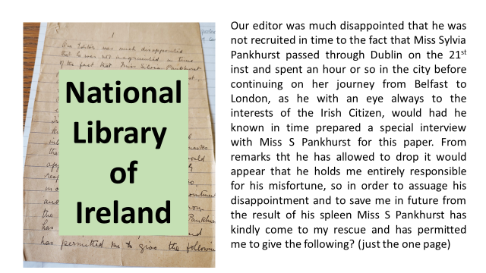
This letter shows that an opportunity was missed when Sylvia travelled through Dublin to Belfast. As it mentions the editor as “he”-it likely to be 1915. It is recorded elsewhere that Hanna took over as editor after Francis was murdered in 1916. Page 2 was missing.

SLIDE 13 Letter from Sylvia to Hanna 1916
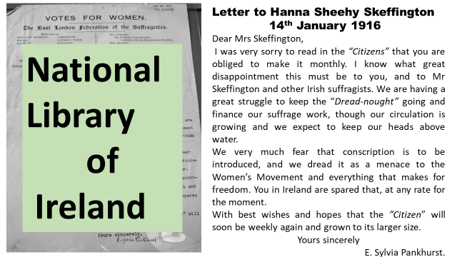
One of letters that I found (above) was sent in 1916 relating to conscription and the difficulties of producing the papers, Dreadnought and the Citizen.
“We very much fear that conscription is to be introduced, and we dread it as a menace to the Women’s Movement and everything that makes for freedom. You in Ireland are spared that, at any rate for the moment.”

Slide 14; From Maude Gonne McBride to Hanna Sheehy Skeffington: I note how the formal address at the beginning that changes to very familiar at the end of the letter.

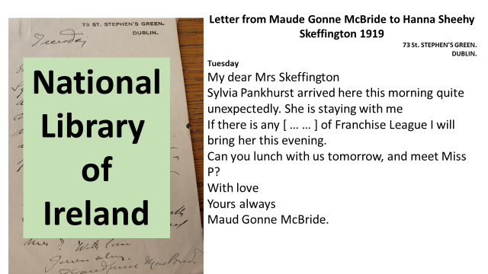

Slide 15 Note to Sylvia to Hanna 1919 Asking to meet with Hanna

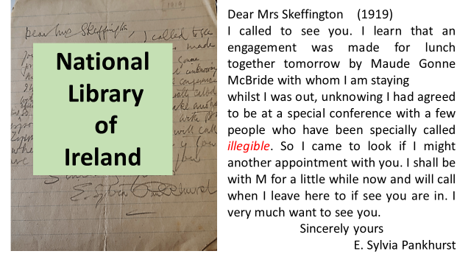

These letters show that Sylvia continued to visit Ireland in 1915,1919 the early 1920’s. Also when she wrote in her unpublished manuscript “I attend Dáil Éireanne (1922-1937), the Limerick Soviet (1919), the Civil War (1922-24) (Rachel Holmes-Page 499, 2020)
In 1931, Hanna wrote to Sylvia, saying: “I know of no English rebel who understands the Irish situation and the international one so well. The comments and sympathy of English comrades drive me mad at times, as they show such a blind spot where we are concerned, in fact our friends are the worst. Your paper, Dreadnought, was always fine.’

SLIDE 16
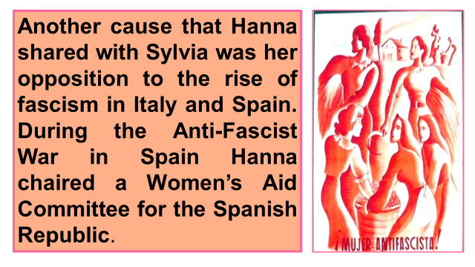
Hidden history and women
I don’t need to explain to this audience the way that women have been hidden from history and how current developments in women’s history grew directly from the contemporary Marxist and feminist movement. A brief look at Irish history books would show that women were very much hidden from history.
Historian Mary Cullen draws attention to the fact that the international women’s emancipation movement was highly visible but bypassed by many historians.

SLIDE 17 books
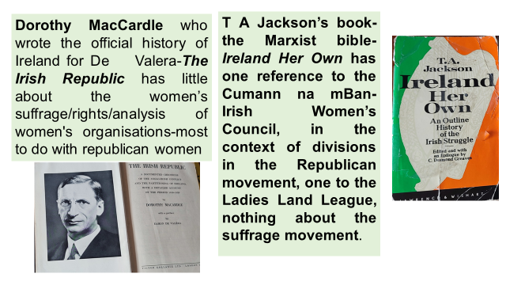
Some examples include TA Jackson’s book-the Marxist bible- Ireland Her Own has one reference to the Cumann na mBan- Irish Women’s Council, in the context of divisions in the Republican movement, one to the Ladies Land League, non to the suffrage movement.”
Dorothy MacCardle who wrote the official history of Ireland for De Valera-The Irish Republic has little about the struggle of women’s suffrage-and women’s rights, Ladies Land League.

SLIDE 18 Field Day Anthology
We can expect that of the past but in three volumes of Field of Irish Writings published in 1991 by Cork University Press caused an outcry from feminist and other historians.
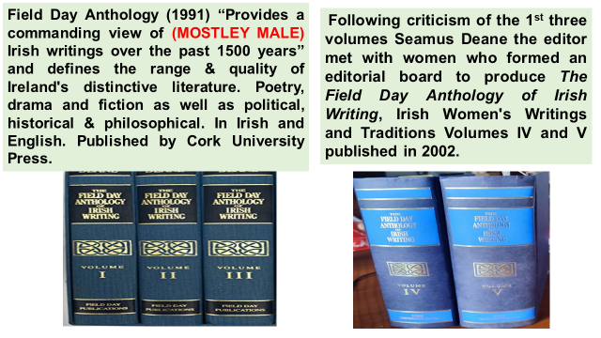

Slide 19 Marxist and Feminist books: Thanks to people like Mary Davis and Rachel Holmes and the National Assembly of Women and the Sylvia Pankhurst Memorial Committee, for the work they have done in raising the profile of Sylvia.
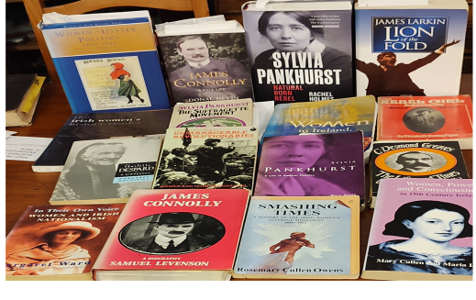
Finally, I admire the common cause that Sylvia shared in opposition to the First World War with not just with James Connolly, Hanna Sheehy Skeffington, Margaret Cousins, but also with Clara Zetkin, and Rosa Luxemburg who were imprisoned in Germany for their anti-war activism and in America, Elizabeth Gurley Flynn and other IWW leaders who were charged with espionage. I feel that we should be supporting the movement for peace in the Ukraine. Opposition to NATO and the billions being spent on weapons. Also the need to support Irish neutrality.
___________________________________________________________________
Some quotes of interest:
“Equal rights for women, guaranteed by the earlier proclamations of Connolly, were stricken from the 1937 constitution, causing Mrs Skeffington to campaign in protest. James Connolly would have scornfully repudiated De Valera’s friendship with Franco and his act in sending official condolences on the death of Hitler. A free worker’s republic was Connolly’s ideal.” (Flynn Elizabeth Gurley, The Rebel Girl-An Autobiography, p275-276:1955)
“In Cork the Munster Women’s Franchise League bought an ambulance and presented it to the military authorities. Mary MacSwiney now a committed republican severed her connections with the suffrage movement, she had come to the conclusion that the majority of the leagues were Britons first, suffragist second, and Irish women perhaps a bad third.” (Owens Rosemary Cullen p 97/98: 1995 Smashing Times)
“James Keir Hardy stood resolutely for peace and brotherhood among the nations-refusing to sanction the claim of the capitalist class of any nation to be the voices of the best interest of that nation.” (Connolly James; p62 Workers Republic October 2 1915: in Labour and Easter Week 1916 1949-Dublin at the Sign of the Three Candles)
“Women are at once the boldest and most unmanageable revolutionaries” Eamon De Valera, in conversation with W.H. Van Voris, Dublin in June. (Ward Margaret in Unmanageable Revolutionaries; [p] 1983)

Slides not included in the talk.
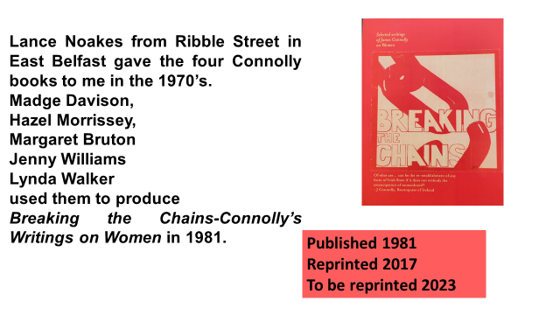

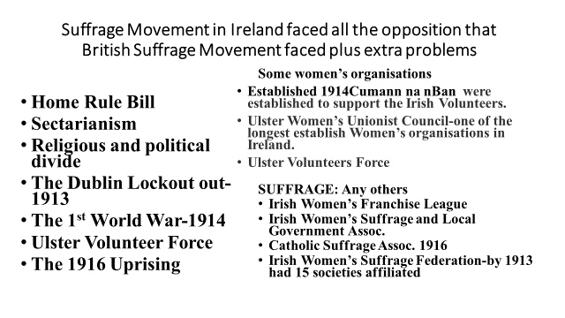

“None so fit the break the chains as those who wear them” Sylvia Pankhurst Lecture Wortley Hall 5th August 2023- Lynda Walker
Bibliography
Burke Angela et al (eds) (2002) The Field Day Anthology of Irish Writing, Irish Women's Writings and Traditions. Volume V. Cork University Press and in the United States and Canada, by New York University Press.
Connolly James (1915) Chapters: Woman; Schools and Scholars of Ireland, in The Reconquest of Ireland in Labour in Ireland, At the Sign of the Three Candles-Dublin
Cullen Owens Rosemary (1995) Smashing Times, Attic Press
Davis Mary (1999) Sylvia Pankhurst-A life in Radical Politics, Pluto Press
Flynn Elizabeth Gurley (1976) The Rebel Girl- An Autobiography-My First Life (1906-1926), International Publisher New York
Greaves CD (1986) The Life and Times of James Connolly, Lawrence & Wishhart
Hayes Alan, Urquhart Diane (eds) (2001) the irish women’s history reader, Routledge.
Holmes Rachel (2020) Sylvia Pankhurst-Natural Born Rebel, Bloomsbury Publishing plc.
Jackson T A (1985) Ireland Her Own-An Outline History of the Irish Struggle, Lawrence & Wishhart.
Levenson Samuel (1973) James Connolly- A Biography, Martin Brian & O’Keeffe.
Luddy Maria (1999) Women in Ireland,1800-1918, Cork University Press.
McCardle Dorothy (1937) The Irish Republic, Victor Gollancz London.
Mulvihill Margaret (191989) Charlotte Despard-A biography, Pandora.
Nevin Donal (ed) (1998) James Larkin-Lion of the Fold, Gill & McMillan.
Nevin Donal (2006) James Connolly A full life, Gill & McMillan.
Pankhurst Sylvia (19) The Suffragette Movement, Virago.
Pankhurst Sylvia (1932) The Home Front, Cresset Library.
Skeffington Hanna Sheehy (1941) Reminiscences of an Irish Suffragette, in Burke Angela et al (eds) (2002) The Field Day Anthology of Irish Writing, Irish Women's Writings and Traditions, Volume V p90-99, Cork University Press and in the United States and Canada 2002, by New York University Press.
Urquhart Diane (2000) Women in Ulster Politics. 1890-1940, Irish Academic Press.
Walker Lynda (ed) (2017) Breaking the Chains-Selected Writings of James Connolly on Women, Communist Party of Ireland.
Ward Margaret (1983) Unmanageable Revolutionaries, Brandon.

Rachel Holmes writes, “the father of Máire Nic Shiubhlaigh printed the proclamation.” (2020, p192) Whereas Margaret Ward writes that “Máire Nic Shiubhlaigh’s father Frank was a printer and he agreed to print replicas of the proclamation, which the ICA posted around the city.” (For the first anniversary of Rising). (1983, p 122)
Rachel Holmes puts Sylvia Pankhurst in Dublin in 1916 when she writes: “Only much later did it become public that she had been in Ireland during the Easer Rising. In her unpublished manuscript “the Inheritance” Sylvia tantalizingly outlines her preparatory notes for writing about being in the thick of it: “What I knew of the Irish rebels. Larkin, Connolly, Countess Markievicz, Arthur Griffith, De Valera and others. I debated the Abbey Theatre under the chairmanship of W.B.Yeats. I attended the Dail Eireanne during the Civil War. I am close to the bayonets. A shot is fired over our heads. The Limerick Soviets. The Dreadnought is raided for expressing sympathy with the Irish Rebels. Maude Gonne McBride and her son. Ireland as a whole. Dublin-the beautiful city in decay. A.E. George Russell-poet painter and This would be financial expert of cooperators. A general view of Irish politics. The Labour party. Tom Johnson and O’Brien. Liberty Hall a land of grief and reaction.” (497-498, 2020) This excerpt from Sylvia’s manuscript is tantalising however more detail is needed to show that Sylvia was in Dublin during the Rising, especially as she puts herself in Newcastle with others (p321,1987). Some of the detail relates to 1919, Limerick Soviet, Dail Eireanne 1922-24, Civil War, Yeats was in England during the rising and Larkin was in America. Having opened up this window it would be useful if we could produce more evidence confirm this.

